Figure List
PartⅠ

Chapter 3 Ground Improvement without Admixture in Cohesive Soils (Figs)’19.1.09

Fig.3.1 Road embankment by Replacement method.
Fig.3.2 Breakwater foundation by Replacement method.
Fig.3.3 Replacement by Light-weight materials.
Fig.3.4 Replacement by surcharging and squeezing.
Fig.3.5 Under-fill Style
Fig.3.6 Flow of Design for Replacement method.
Fig.3.7 foundation of Gentle sloping revetment bank by Replacement method
Fig.3.8 Consolidation curve of Preloading method (Ishibasi & Hazarika 2010)
Fig.3.9 Preloading by embankment
Fig.3.10 Sand Drain Method
Fig.3.11 Vacuum Consolidation Method
Fig.3.12 Principle of vertical drain method (Ishibasi & Hazarika, 2010)
Fig.3.13Wick drain (Ishibashi & Hazarika, 2010)
Fig.3.14Procedures of Sand Drain Method with Casing Pipe
(Catalogue of Nihon Kaiko Co. Ltd.)
Fig.3.15Prefabricated Typical Wick Drain (JGS, 2006)
Fig.3.16Mandrel-type Machine for Wick Driving
Fig.3.17 Relationship of T_{h} and U on Vertical Drain (Takagi, 1955)
Fig.3.18 Pattern of Sand Pile and Effective Distance
Fig.3.19 Seawall Foundation and Soil Profiles of Kansai International Airport (Furudoi & Kobayashi)

CL

Replaced sand

Soft ground
Soft ground

Fig.3.1 Road embankment by Replacement method (Nishida and Nakazawa, 1991).

Replaced sand
Soft ground
Soft ground
Rubble mound
Caisson
Rip-rap mound
Fig.3.2 Breakwater foundation by Replacement method (Nishida and Nakazawa, 1991).

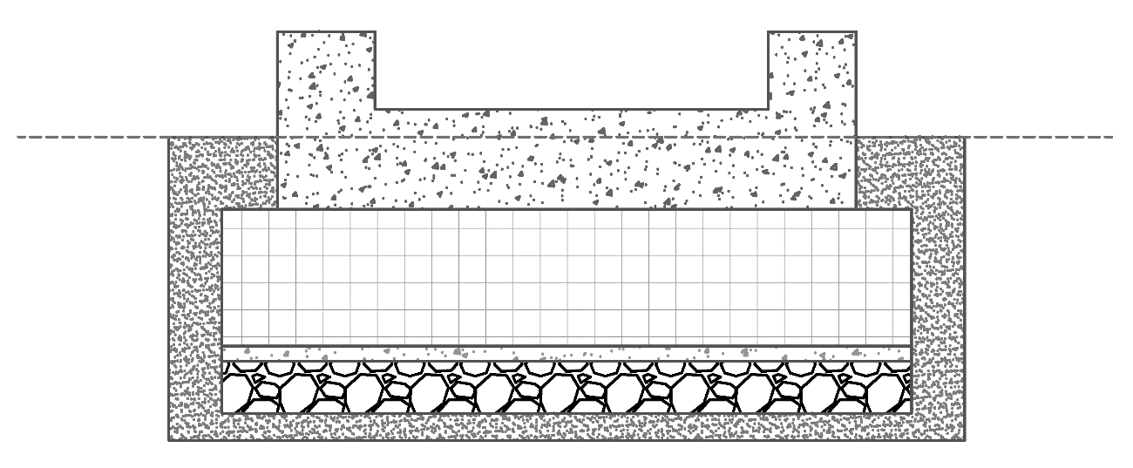
Expanded polystyrene
Leveling concrete
GL
Mat foundation
Crushed stone
Fig.3.3 Replacement by Light-weight materials.

Embankment

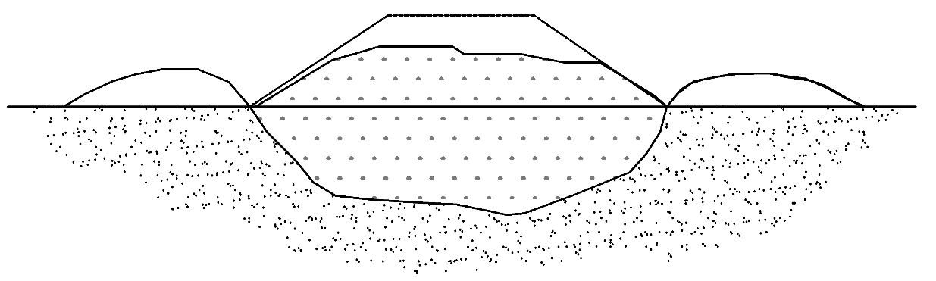
Soft ground
Squeezing out by slip failure

Fig.3.4 Replacement by surcharging and squeezing (Nishida and Nakazawa, 1991).
(d) Final stage of blasting
Fill
Cavity
(c) Blasting of main explosive
Fill
Main explosive Cavity
(b) Blasting of sub-explosive
Fill

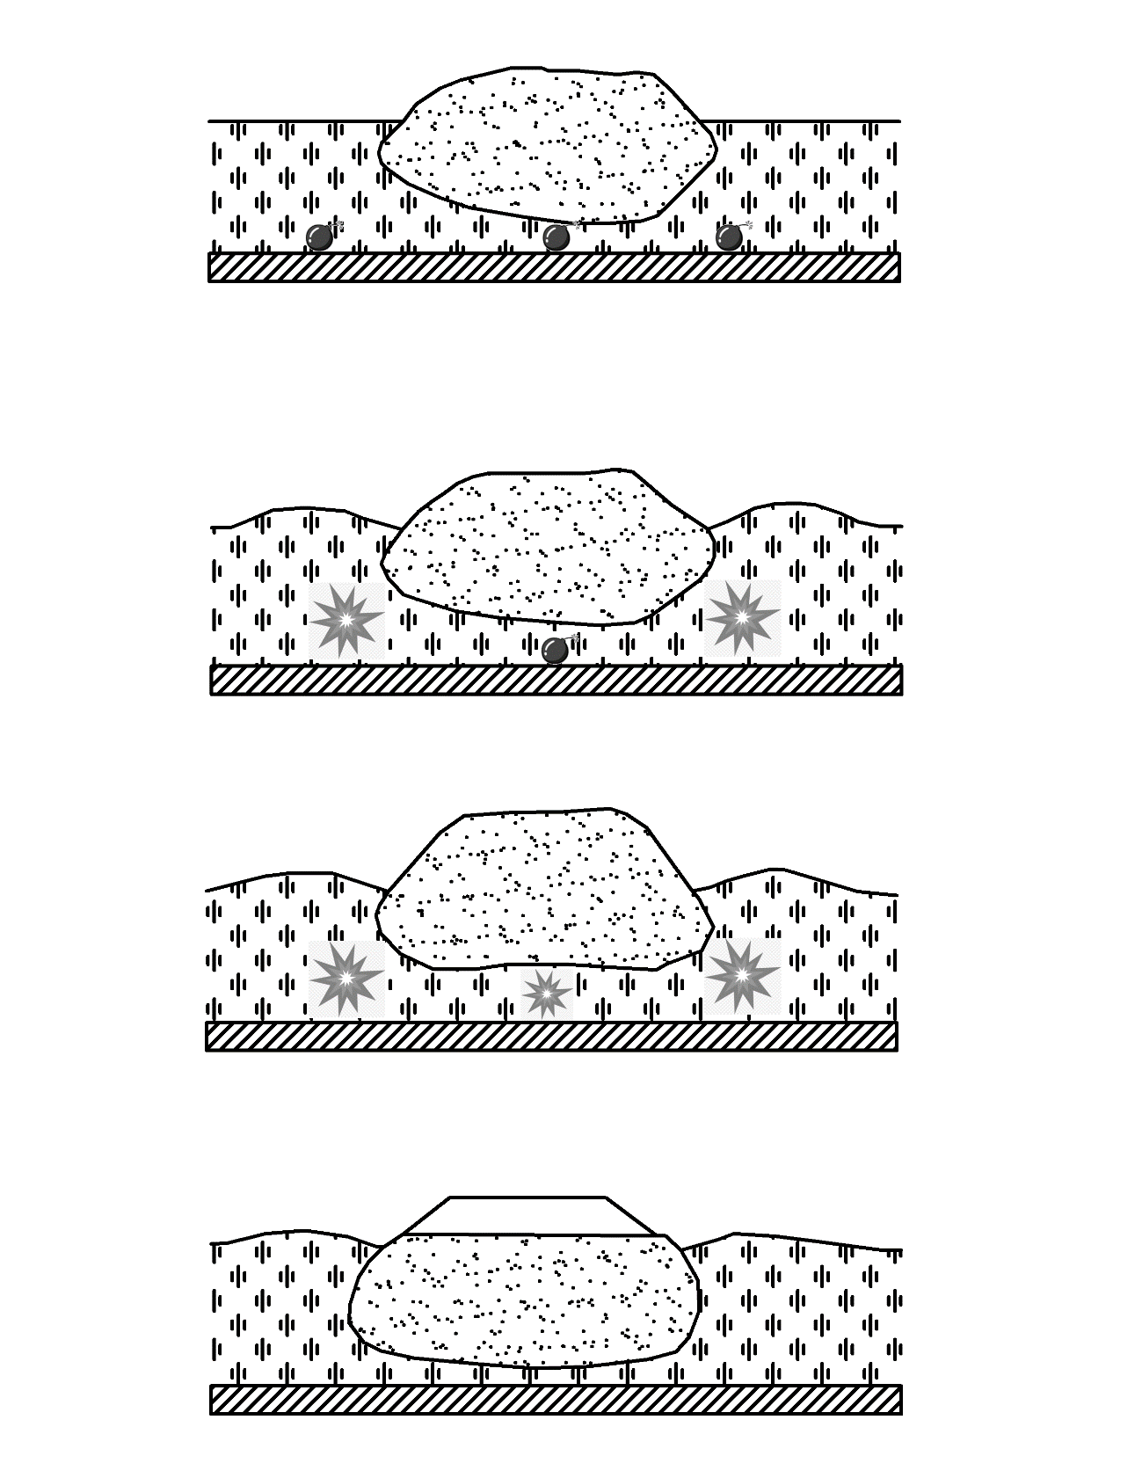
Main explosive

(b) Blasting of sub-explosive
Cavity
Cavity
Cavity

(c) Blasting of main explosive
Cavity
Fill
Fill
Fill
(d) Final stage of blasting
Fill
Soft ground
Sub-explosive Main explosive Sub-explosive

(a) Laying of explosives

Fig.3. 5 Under-fill style (Nishida and Nakazawa, 1991)

Design condition

Soil condition

Tentative condition
of structure or filling

Stability analysis
NO

Yes

NO
Comparison

Yes

Examination for settlement and bearing capacity

Fig.3.6 Flow of Design for Replacement method (Nishida and Nakazawa, 1991).

30% SCP
▽AP-42.00m
▽AP.-20.00m
▽HWL. AP+12 m
▽HWL. AP+2.1 m
Embankment 2
1:2
Replacement
60% SCP

60% SCP
Sand Drain
Reclaimed Land
1:2
Riprap
Embankment
Fig.3.7 Foundation of Gentle sloping revetment bank by Replacement method (Horiuchi et al., 2008)

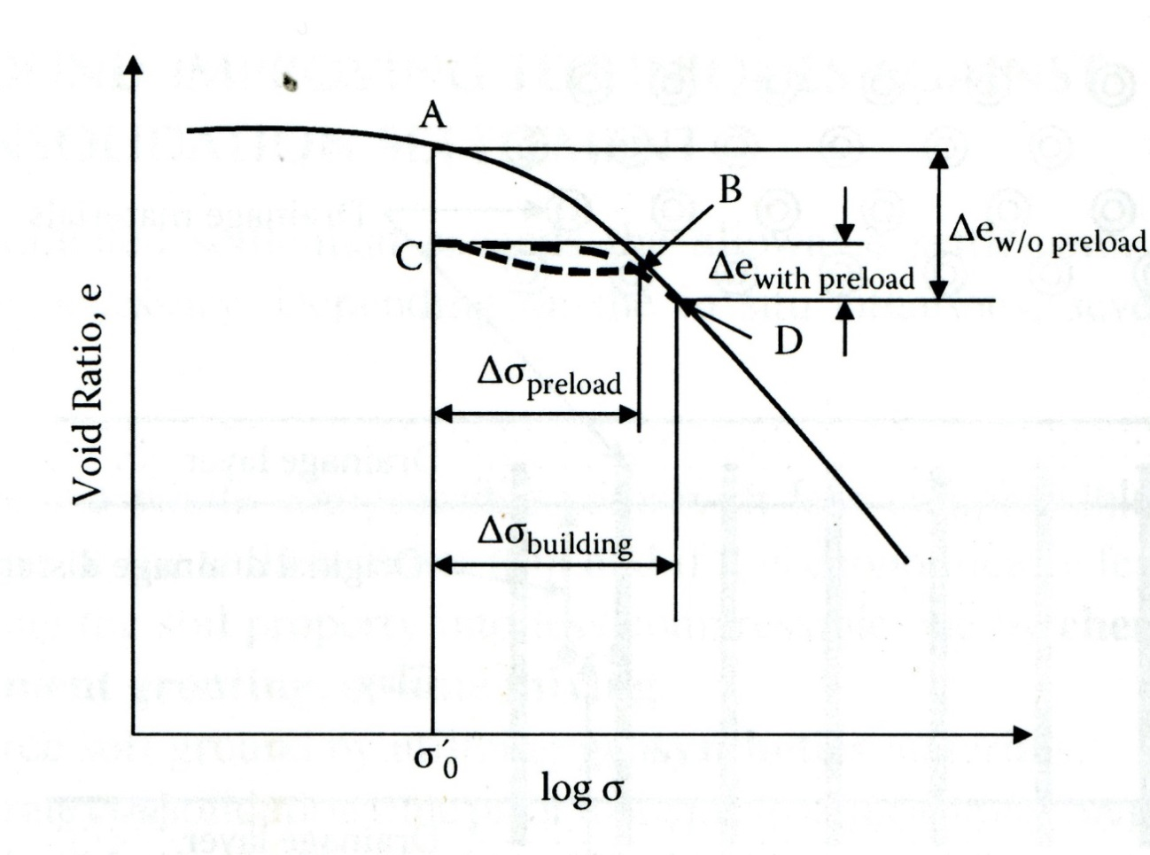
Fig.3.8 Consolidation curve of Preloading method (Ishibasi & Hazarika 2010)

（オリジナルを入れる）

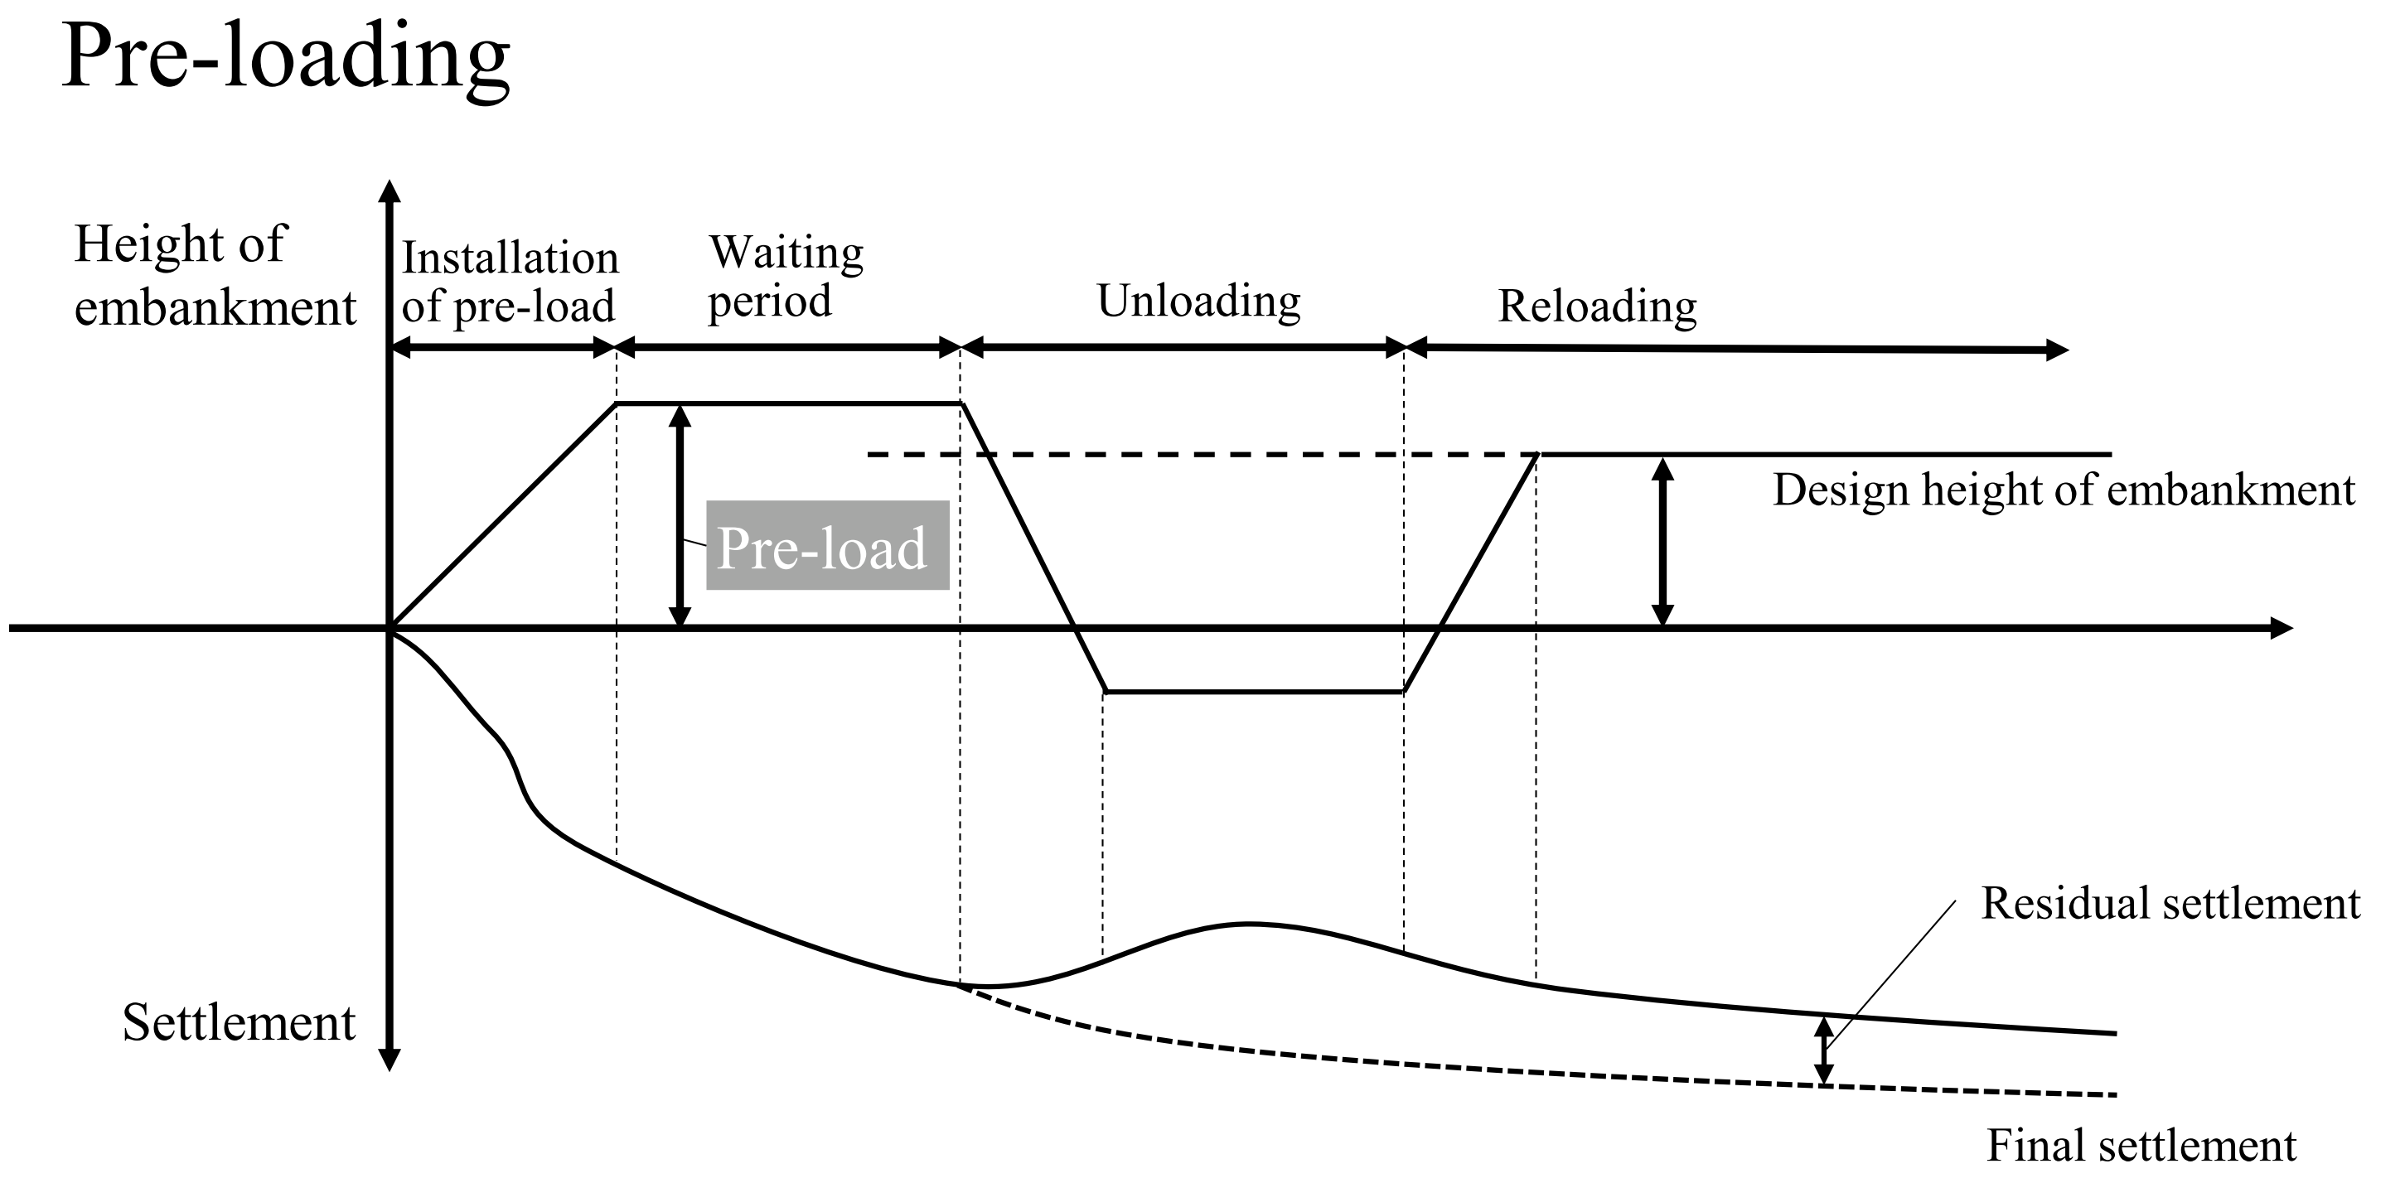
Fig.3.9 Preloading by embankment

Permeable sand layer
Soft clayey soil
Sand drains
Water flow
Sand mat
Embankment as surcharge

Fig.3.10 Sand drains method

Vacuum pump
Air & Water
Sand mat with drain pipes
Airtight membrane
Vertical drainage materials
Fig. 3.11 Vacuum consolidation method

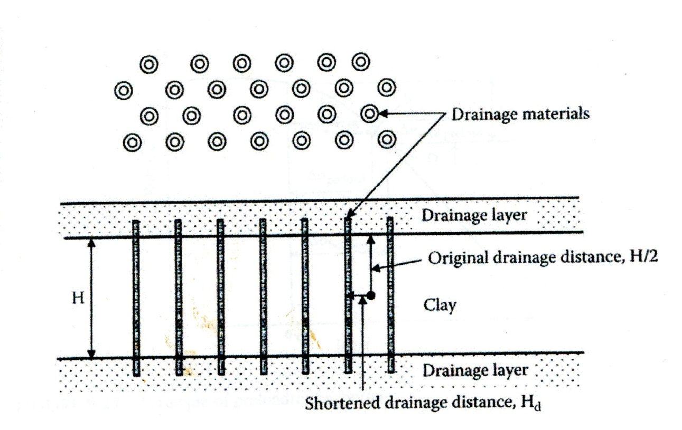
Fig.3.12 Principle of vertical drain method (Ishibasi & Hazarika, 2010)
（オリジナルを入れる）

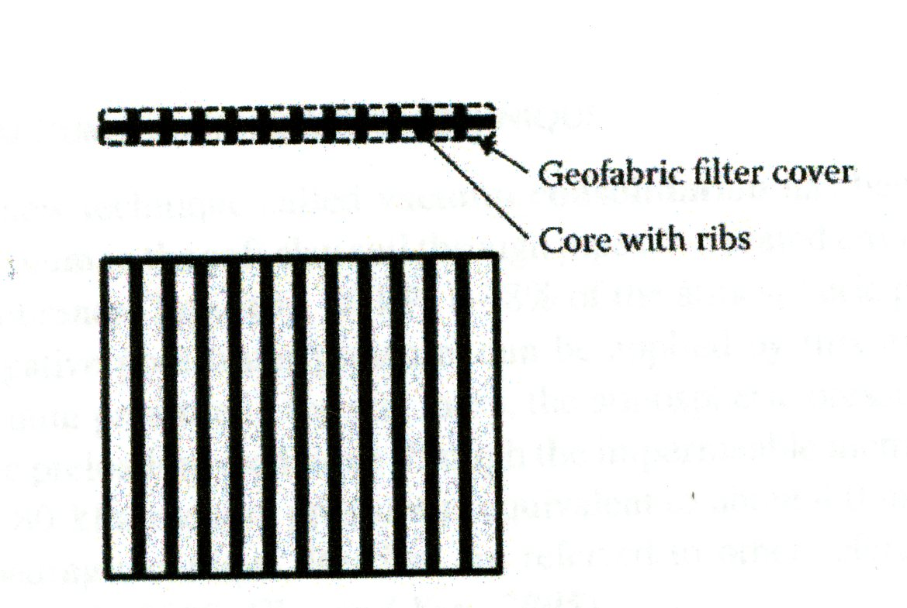
Fig.3.13 Wick drain (Ishibashi & Hazarika, 2010)
（オリジナルを入れる）

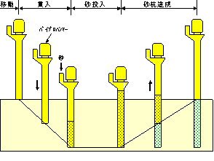
Molding of Sand Pile
Installation
Driving & Penetration
Supply of Sand
Sand
Vibro-Hammer
Fig.3.14 Procedures of Sand Drain Method with Casing Pipe
(Catalogue of Nihon Kaiko Co. Ltd.)

若干修正（学生アルバイト）

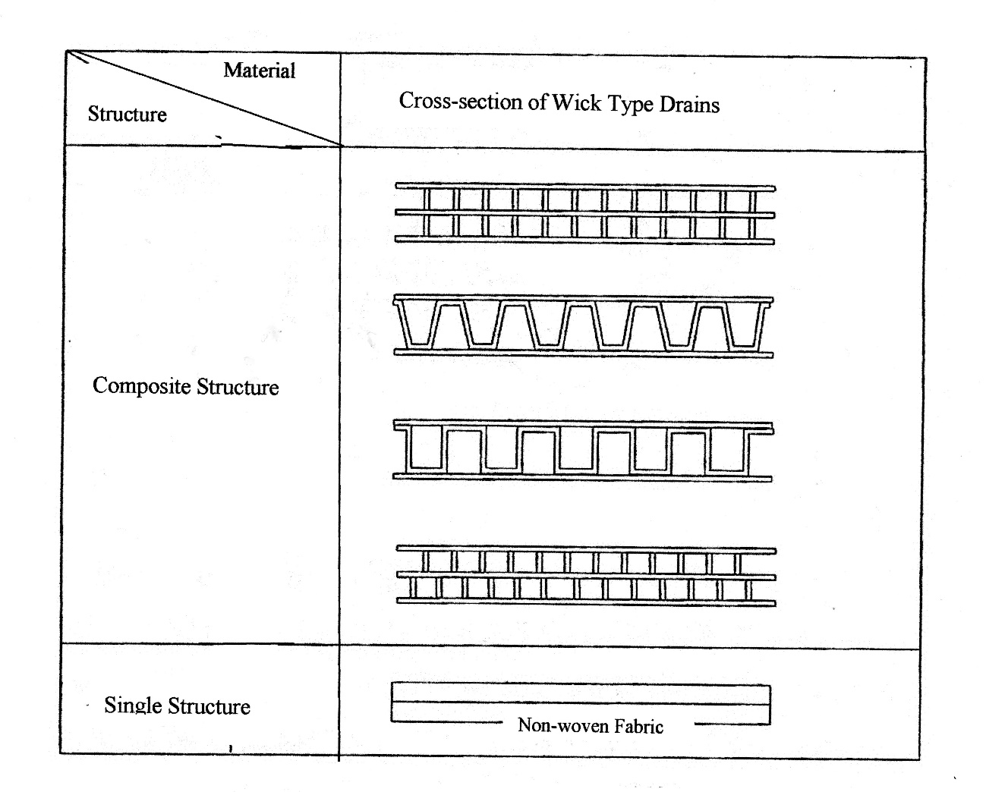
Fig.3.15 Prefabricated Typical Wick Drain (JGS, 2006)

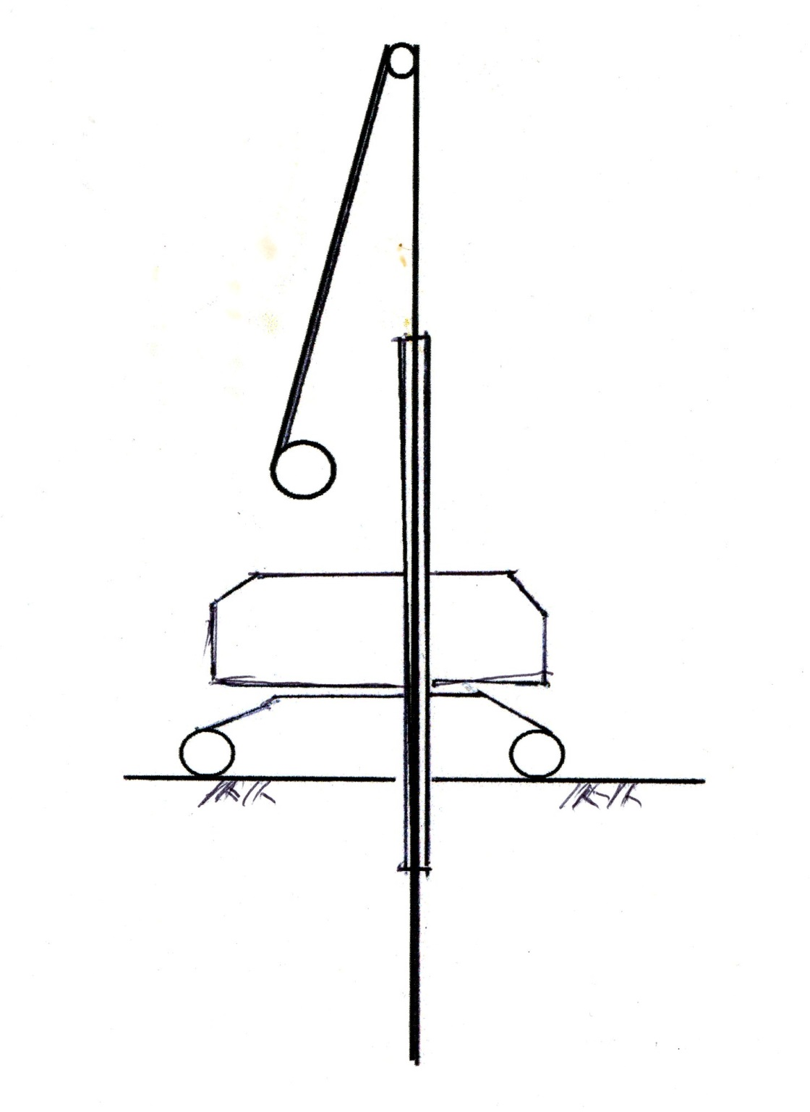
Fig.3.16 Mandrel-type Machine for Wick Driving
(図を書き直す；学生アルバイト)

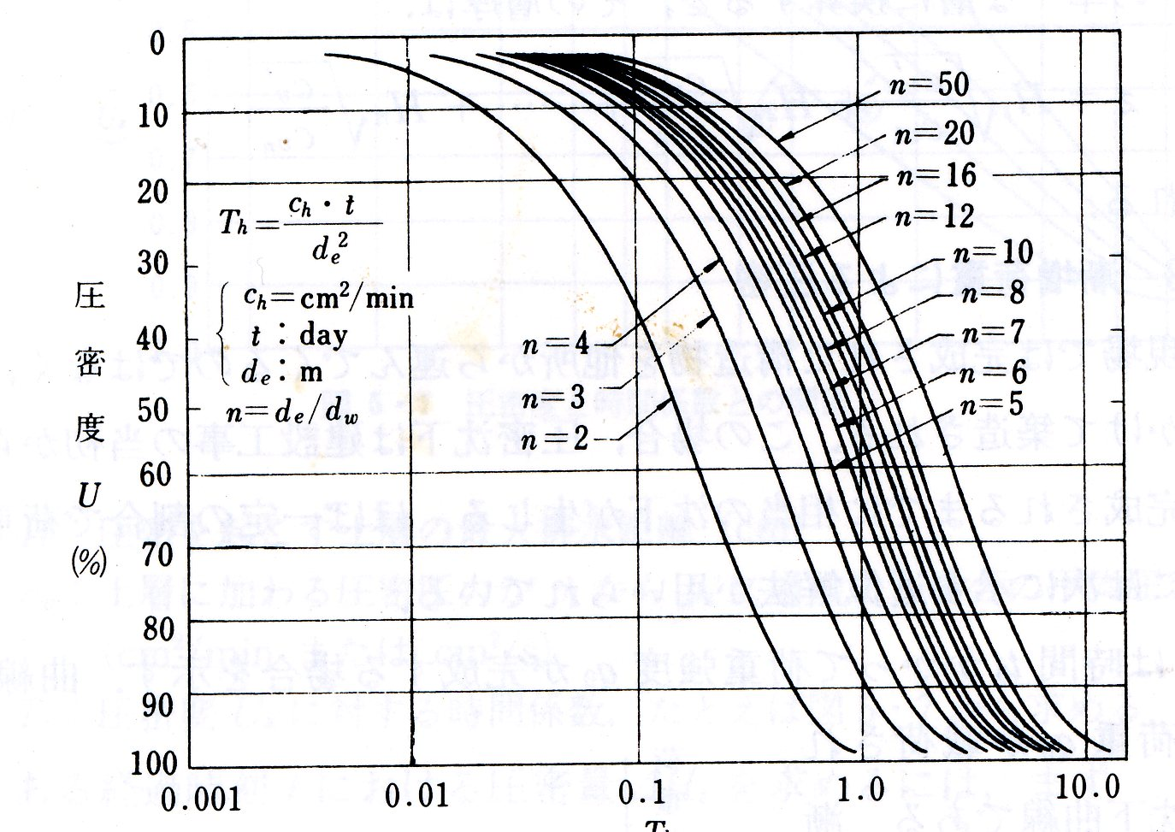
Degree of Consolidation U (%)
Time Factor T_{h}

Fig.3.17 Relationship of T_{h} and U on Vertical Drain (Takagi, 1955)

（図をもう一度スキャンする）学生アルバイト

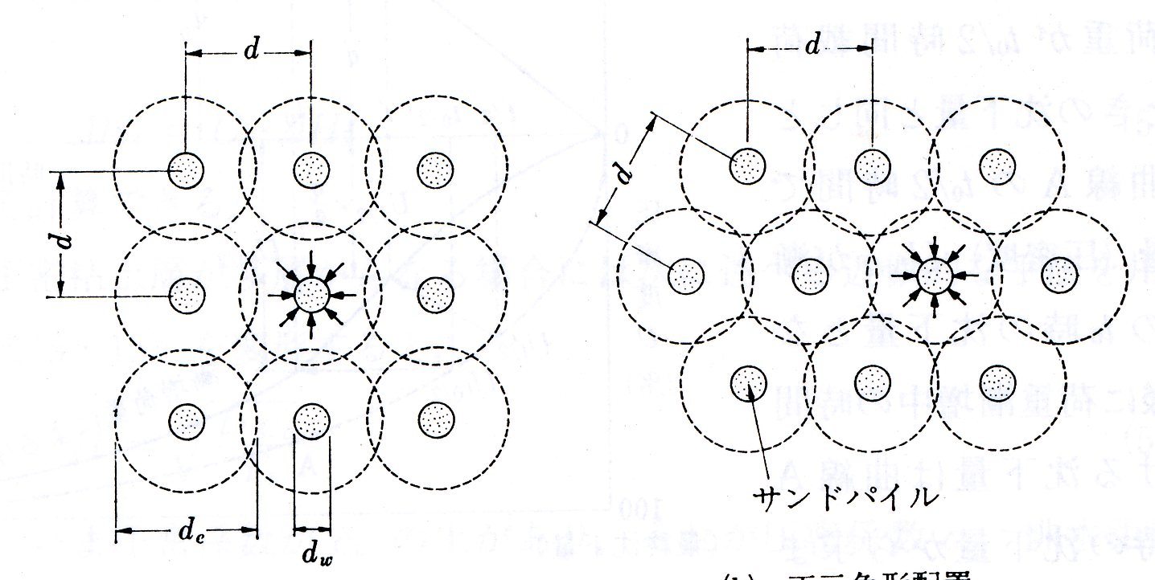
Sand pile

Fig.3.18 Pattern of Sand Pile and Effective Distance (参考文献を入れる：高木論文？)

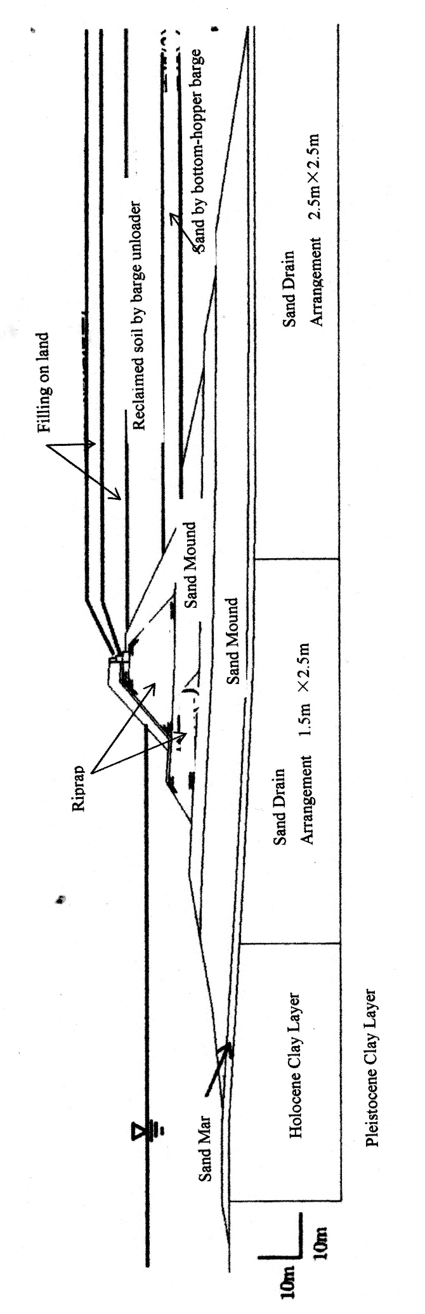

Fig.3.19 Seawall Foundation and Soil Profiles of Kansai International Airport (Furudoi & Kobayashi, 2009)

